**To run the whole prediction process:**

**Step 1:**

Go to :

*<https://www.kaggle.com/competitions/home-credit-credit-risk-model-stability/data?select=parquet_files>*

And click:

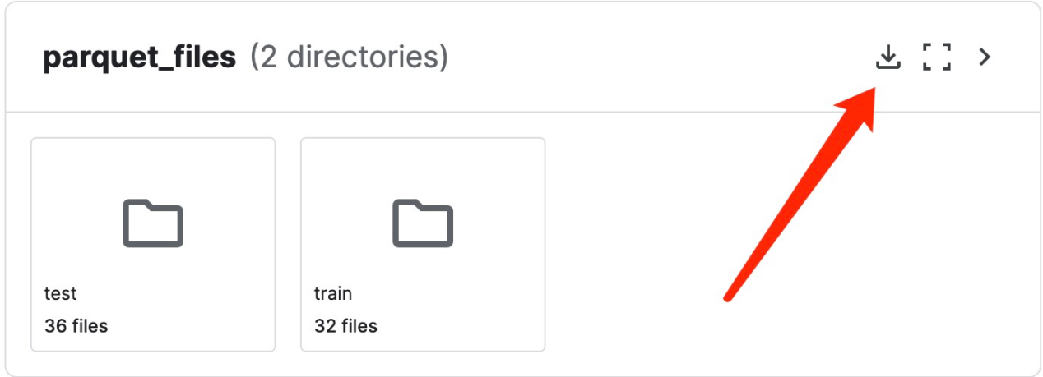

To download the parquet file contents for train and test.

Then put all the parquet files in a single file folder, say QF5214_project_G9.

**Step 2:**

Go to:

*<https://github.com/Shyffsy/QF5214_group_9/tree/master>*

And download files:

- ranged_iv_for_train_features.pkl

- PSI_map.pkl

- QF5214_Group9_Project.ipynb

Put all these files also in the QF5214_project_G9 folder.

**Step 3:**

Enter you Jupyter environment, enter QF5214_project_G9 folder and open the ipynb file:

QF5214_Group9_Project.ipynb

Click run Kernel - Restart and Run ALL and you will get the final result.

**To test the database we created:**

- Enter 47.250.55.122

- Enter qf pacakge

- Find DataBase_Check.ipynb file and open it

- Click run Kernel - Restart and Run ALL and you will get the result. You can also try different SQL instructions in:

pd.read_sql_query("*Type your instructions here*", conn1)